**__________________________________________________**

**UC Portal v.2.7.d.e2 Emergency Fix Release**

**Deployment Document Version 1.0**

**05/09/2017**

Prepared by: Applied Intellect LLC.

**Revision History**

|  |  |  |  |
| --- | --- | --- | --- |
| DATE | VERSION | AUTHOR | DESCRIPTION |
| 05/09/2017 | 1.0 | Dilmurat Sulayman | Initial Document |
| 05/19/2017 | 2.0 | Dilmurat Sulayman | Added Program Documents Upload to this release. |

Table of Contents

1 Introduction 4

1.1 Project Objectives 4

1.2 Stakeholders 4

1.3 Definitions 4

2 Instructions 5

# Introduction

The purpose of this document is to provide deployment instructions for Emergency Release UAC Portal v.2.7.d.e2

## Project Objectives

The objective of effort is to show UAC Images on the HTML generated PDF files.

## Stakeholders

|  |  |  |  |
| --- | --- | --- | --- |
| Name | Department | Role | Sign-off Received |
| Virak Kchao | ORR | Sign-off |  |

## Definitions

None

# Deployment Instructions

1. Shutdown IIS

Open “Server Manager” and click on “Tools” Link

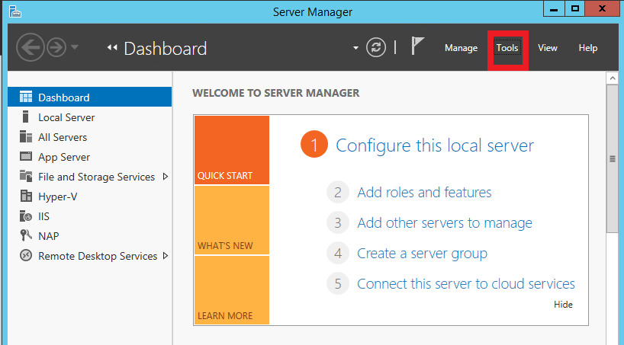

Then select “IIS Manager” from the list

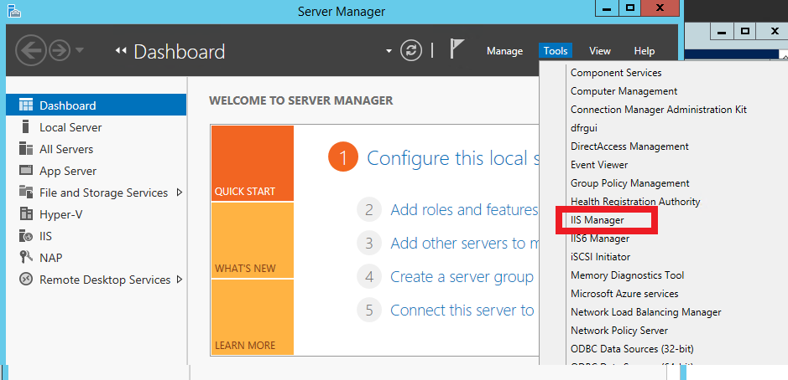

Highlight the IIS Root and Click “Stop” on the link in the right action panel

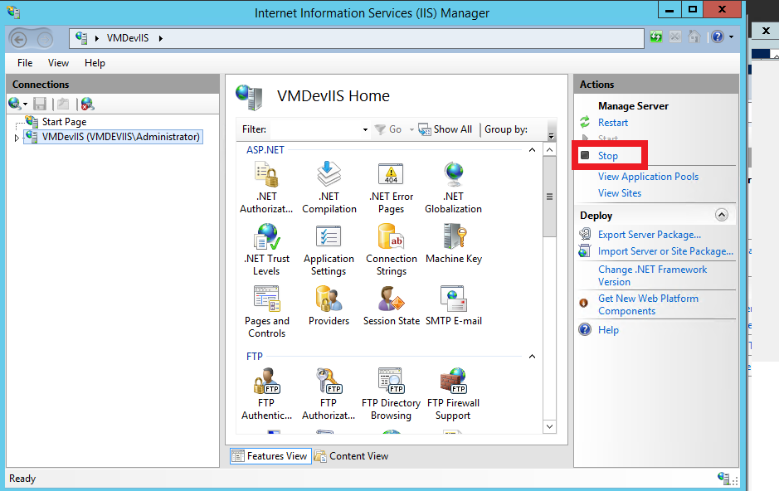

1. Unzip the contents of the Deployment package in to a temporary folder [unzipped temporary folder].
2. Back up C:\UACPortal folder
3. Copy all the files and folders from [unzipped temporary folder]\UACPortal into C:\UACPortal folder and overwrite existing files.
4. Copy following documents from [unzipped temporary folder]\Documents to [FileServer]\UAC_DOCUMENTS\Documents folder
   * UC-Portal-Flyer.pdf
   * UC-Portal-Moving-Flyer.pdf
5. **Documents to be uploaded into the portal for new and existing programs**
   * Unzip the UAC Portal v.2.7.e2 File Upload v1.0.zip package to a temporary folder [unzipped temporary folder].
   * Copy the files from the [unzipped temporary folder]\DocumentUpload folder to the related folders specified in the following table.

|  |  |
| --- | --- |
| **File Name** | **File Location** |
| Abbott House _LTFC_v1.0.docx | C:\UAC_DOCUMENTS\Documents\Program Descriptions\LTFC |
| Abbott House_Shelter_v1.0.docx | C:\UAC_DOCUMENTS\Documents\Program Descriptions\Shelters |
| BCFS Baytown_Shelter_v1.0.docx | C:\UAC_DOCUMENTS\Documents\Program Descriptions\Shelters |
| BCFS Chavaneaux_Shelter_v1.0.docx | C:\UAC_DOCUMENTS\Documents\Program Descriptions\Shelters |
| BCFS Raymondville_Shelter_v1.0.docx | C:\UAC_DOCUMENTS\Documents\Program Descriptions\Shelters |
| BCFS San Antonio_Shelter_v1.0.docx | C:\UAC_DOCUMENTS\Documents\Program Descriptions\Shelters |
| Bethany Christian Services Maryland_TFC_v1.0.docx | C:\UAC_DOCUMENTS\Documents\Program Descriptions\TFC |
| Board of Child Care_LTFC_v1.0.docx | C:\UAC_DOCUMENTS\Documents\Program Descriptions\LTFC |
| Board of Child Care_Shelter_v1.0.docx | C:\UAC_DOCUMENTS\Documents\Program Descriptions\Shelters |
| Board of Child Care_TFC_v1.0.docx | C:\UAC_DOCUMENTS\Documents\Program Descriptions\TFC |
| Center for Family Services_Shelter_v1.0.docx | C:\UAC_DOCUMENTS\Documents\Program Descriptions\Shelters |
| Center for Family Services_TFC_v1.0.docx | C:\UAC_DOCUMENTS\Documents\Program Descriptions\TFC |
| IES Casa Norma Linda_Shelter_v1.0.docx | C:\UAC_DOCUMENTS\Documents\Program Descriptions\Shelters |
| JCCA_LTFC_v1.0.docx | C:\UAC_DOCUMENTS\Documents\Program Descriptions\LTFC |
| KidsPeace_Shelter_v1.0.docx | C:\UAC_DOCUMENTS\Documents\Program Descriptions\Shelters |
| Leake and Watts_LTFC_v1.0.docx | C:\UAC_DOCUMENTS\Documents\Program Descriptions\LTFC |
| Youth for Tomorrow_LTFC_v1.0.docx | C:\UAC_DOCUMENTS\Documents\Program Descriptions\LTFC |

1. Restart IIS (See above image, click on Restart button)

